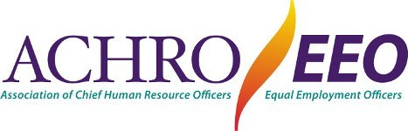

Throughout the spring and summer, the Association of Chief Human Resources Officers and Equal Employment Officers (ACHRO) has been working on a comprehensive set of strategy recommendations to rethink the way California community colleges market employment opportunities, request and receive applications, define and evaluate key qualifications and skills, screen and select candidates to advance through the hiring process, and write and conduct interviews. In each of these phases of the recruitment and selection process, ACHRO’s recommendations establish Diversity, Equity, and Inclusion (DEI) related skills and engagement as essential for success in any role within a community college district.

ACHRO’s focus for fall and spring is collaborating with our partners in the DEI Implementation Workgroup to continue refining the recommendations and building wide support for transforming our conventional screening and selection processes. The process begins with an understanding that conventional hiring practices used widely in public and private employment were developed decades ago when discrimination based on race, ethnicity, gender, ability status, and many other characteristics was legal, encouraged, and expected. The biases and preferences built into these processes continue to create barriers to diversity, deny individuals meaningful inclusion, and prevent us from achieving equitable outcomes.

The overarching theme of ACHRO’s recommendations is that the ability to work with, educate, and serve diverse communities successfully is an essential qualification for every position. The California community colleges are uniquely positioned by our mission, vision, and values, to recruit and retain people committed to serving diverse communities with a strong understanding of the lived experiences of our students.

With the support of our peer stakeholders in the DEI Implementation Workgroup, ACHRO is planning to pilot the new screening and selection processes with a select group of colleges. We will work with a consulting organization to collect data on the outcomes of the pilot, recommend strategic revisions, and share the results widely. With qualitative and quantitative data supporting the effectiveness of the strategies, ACHRO will work with its partners to encourage all Districts to adopt DEI-focused revisions to their employment practices.

ACHRO looks forward to support from the Board of Governors and Chancellor’s Office to promote a bold redesign of our conventional employment processes, assistance in conducting trainings across the system, and identifying ways to encourage and incentivize Districts to join in establishing DEI as a fundamental element of how we operate at every level.

