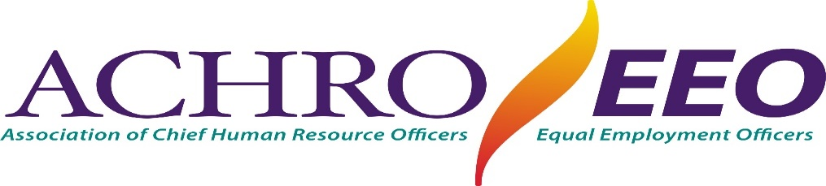

2023 FALL TRAINING INSTITUTE

*= INFORMATION =*

LOCATION – Hyatt Regency Mission Bay, 1441 Quivira Rd., San Diego, CA

Tuesday, October 17 – Pre-Conference, 1:00 p.m. to 5:00 p.m. (be sure to register for the pre-conference)

Wednesday, October 18 – Registration, Breakfast, Lunch & Workshops, 7:30 a.m. to 5:00 p.m.

Thursday, October 19 – Breakfast, Lunch & Workshops, 7:30 a.m. to 5:00 p.m.

Friday, October 20 – Breakfast & workshops, 7:30 a.m. to Noon

***YOU WILL BE NOTIFIED AS SOON AS PROGRAM TOPICS***

***HAVE BEEN DETERMINED***

HOTEL RESERVATIONS

DEADLINE – MONDAY: 9/25/23 – All workshop sessions and events will be held at our conference hotel, Hyatt Regency Mission Bay, where they are offering ACHRO/EEO attendees the special rate of $199, plus tax and fees. **Since only 188 rooms are available at the $199 rate, be sure to book your hotel room ASAP, at the link below:**

<https://www.hyatt.com/en-US/group-booking/SANIS/G-AHRO>

Complimentary self-parking over program dates

Individual credit cards will be charged for first night’s room and tax at the time of reservation

REGISTRATION INFORMATION

TO REGISTER, USE THIS LINK: [2023 ACHRO/EEO Conference Registration](http://jobfairs.cccregistry.org/RegisterCATraining.aspx)

Institute Registration Deadline is 9/29/23. NO REFUNDS AFTER 10/02/23 – REMEMBER, after that date, ABSOLUTELY no refunds, and payment is expected.

Make CHECK payable to ACHRO/EEO and mail to:

Ruth Cortez, ACHRO Assistant

10627 Avonbury Ave. Whittier, CA 90603

email: klavier88@verizon.net

FOR MORE INFORMATION ON ACHRO/EEO, VISIT OUR WEB SITE: www.achroeeo.com